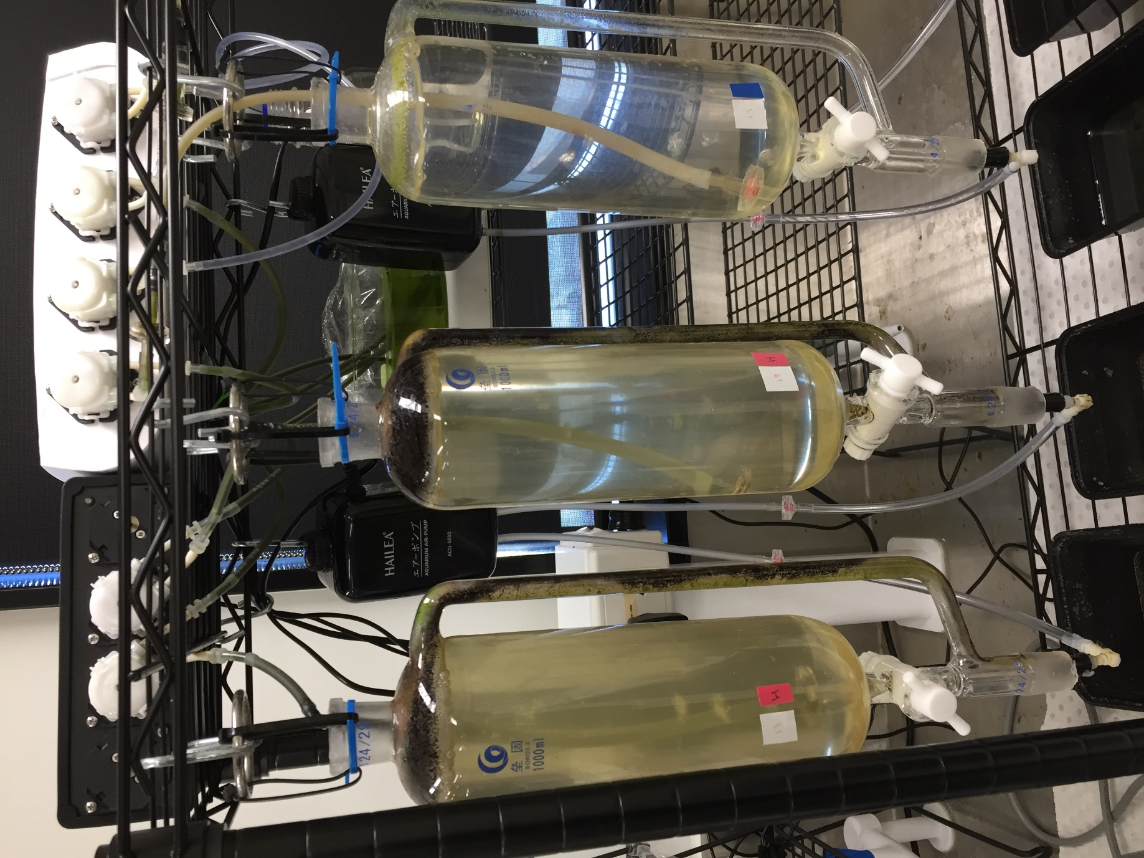

**Figure S2:** 1L glass pressure-equalising dropping funnels used for culturing treatment populations of copepods.